LEXICAL ANALYSER

AIM
To write a C program that performs lexical analysis of a given C statement by identifying and classifying tokens such as keywords, identifiers, constants, arithmetic operators, relational operators, and special symbols.

PSEUDOCODE
START
1. Define a list containing all C keywords.
2. Define function isKeyword(word):
Compare word with each keyword.
If a match is found:
Return 1
Otherwise:
Return 0
3. Read a C statement from the user.
4. Set i = 0.
5. Repeat until the end of the input:
a. If the current character is a whitespace:
Skip it.
b. If the current character is an alphabet or '_':
Read the complete word.
If the word is a keyword:
Display "Keyword"
Else:
Display "Identifier"

c. Else if the current character is a digit:
Read the complete number.
Display "Constant"
d. Else if the character is +, -, *, /, or %:
Display "Arithmetic Operator"
e. Else if the character is =, <, or >:
Check the next character.
If it forms ==, <=, or >=:
Display "Relational Operator"
Else:
Display "Operator"
f. Else if the character is (, ), {, }, [, ], ;, or ,:
Display "Special Symbol"
g. Otherwise:
Display "Unknown Symbol"
6. Continue until all characters are processed.
7. STOP

PROGRAM
#include <stdio.h>
#include <string.h>
#include <ctype.h>
int isKeyword(char str[])
{
char keywords[][20] = {
"auto", "break", "case", "char", "const",
"continue", "default", "do", "double",
"else", "enum", "extern", "float", "for",
"goto", "if", "int", "long", "register",
"return", "short", "signed", "sizeof",
"static", "struct", "switch", "typedef",
"union", "unsigned", "void", "volatile",
"while"
};
int i;
for (i = 0; i < 32; i++)
{
if (strcmp(str, keywords[i]) == 0)
return 1;
}
return 0;
} int main()
{
char input[1000];
int i = 0;
printf("Enter a C statement:\n");
fgets(input, sizeof(input), stdin);
while (input[i] != '\0')
{
/* Ignore white spaces */
if (isspace(input[i]))
{
i++;
continue;
}
/* Identifier or Keyword */
if (isalpha(input[i]) || input[i] == '_')
{
char word[50];
int j = 0;
while (isalnum(input[i]) || input[i] == '_')
{
word[j++] = input[i++];
}
word[j] = '\0'; if (isKeyword(word))
printf("%s\t\tKeyword\n", word);
else
printf("%s\t\tIdentifier\n", word);
}
/* Number */
else if (isdigit(input[i]))
{
char number[50];
int j = 0;
while (isdigit(input[i]) || input[i] == '.')
{
number[j++] = input[i++];
}
number[j] = '\0';
printf("%s\t\tConstant\n", number);
}
/* Arithmetic Operators */
else if (input[i] == '+' || input[i] == '-' ||
input[i] == '*' || input[i] == '/' ||
input[i] == '%')
{
printf("%c\t\tArithmetic Operator\n", input[i]);
i++;
} /* Relational / Assignment Operators */
else if (input[i] == '=' || input[i] == '<' ||
input[i] == '>')
{
if (input[i + 1] == '=')
{
printf("%c%c\t\tRelational Operator\n",
input[i], input[i + 1]);
i += 2;
}
else
{
printf("%c\t\tOperator\n", input[i]);
i++;
}
}
/* Special Symbols */
else if (input[i] == '(' || input[i] == ')' ||
input[i] == '{' || input[i] == '}' ||
input[i] == '[' || input[i] == ']' ||
input[i] == ';' || input[i] == ',')
{
printf("%c\t\tSpecial Symbol\n", input[i]);
i++;
}
else
{
printf("%c\t\tUnknown Symbol\n", input[i]);
i++; }
}
return 0;
}

OUTPUT

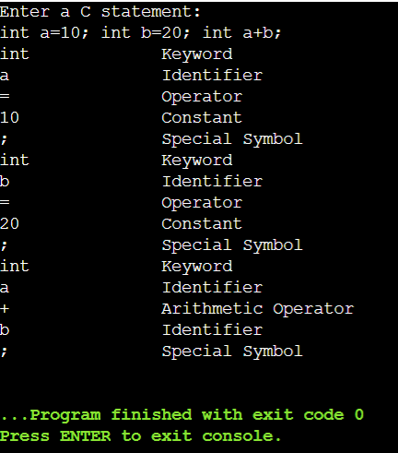

RESULT
The C program was successfully executed and the given C statement was lexically analyzed. The program correctly identified and displayed the tokens as keywords, identifiers, constants, operators, and special symbols.

